ENPM680 Final Project: Phase 2
RetroBytes - A Place for Retro and
Vintage Items

By
Name | Sai Praneeth Koti
Email | ksp@umd.edu
Directory ID | ksp
UID | 121297495

Table of Contents
1. Application Description 4
a. Overview 4
b. Scope 4
c. Functionalities 4
2. Use Cases 5
Use Case #1: Browse Catalog by Category 5
Use Case #2: Check Local Stock Availability 6
Use Case #3: Add Item to Cart & Place Order 7
Use Case #4: Search & Filter by Condition 8
Use Case #5: Save for Later / Wishlist 9
3. Functional Requirements 10
Functional Requirements for Use Case #1: Browse Catalog by Category 10
Functional Requirements for Use Case #2: Check Local Stock Availability 13
Functional Requirements for Use Case #3: Add Item to Cart & Place Order 15
Functional Requirements for Use Case #4: Search & Filter by Condition 18
Functional Requirements for Use Case #5: Save for Later / Wishlist 19
4. External Interface Requirements 21
5. References 24

List of Figures
Figure 1. Browse Catalog by Category 4
Figure 2. Check stock availability 5
Figure 3. Add Item to Cart & Place Order 6
Figure 4. Search and Filter by condition 7
Figure 5. Save product for later 8

1. Application Description

a. Overview
Retro Bytes is a small e-commerce website that is made for people who love retro style products. The site mainly gives a collection of nostalgic items such as retro shoes, vintage radios, old-style electronics, and classic gaming consoles. The design is kept very light and user-friendly, so customers can easily browse and enjoy the shopping experience. The focus is more on showing retro products in a clear way rather than giving too many extra features.

b. Scope
Nowadays many customers are interested in retro or vintage products, but it is not easy to find them all in one place. Most of the big e-commerce platforms are mainly showing modern products, so retro items are not highlighted. Because of this, customers spend a lot of time searching across different websites and still cannot be sure about the product condition or local availability. There is a need for one simple platform where retro items are collected and shown clearly, with details that help users decide before buying.

c. Functionalities
• Browse Products by Category: Customers can explore products by categories like shoes, radios, electronics, and gaming consoles.
• View Product Details and Condition: Each product page shows full details like description, price, and images. It also clearly mentions if the product is first-hand (new but retro-inspired) or second-hand (pre-owned vintage).
• Check Local Stock Availability: Customers can check if the product is available in their location for delivery or pickup by entering their postal code.
• Add to Cart and Simple Checkout: Customers can add products to the cart and finish the order with an easy checkout process.
• Clean and Direct Design: The website is kept clean and lightweight so that navigation is simple and customers can focus only on retro items.

2. Use Cases

Use Case #1: Browse Catalog by Category
- Actor: Customer
- Goal: Explore retro products by categories like shoes, electronics or gaming consoles.
- Success Scenario:
  - Customer opens Retro Bytes homepage.
  - Selects a category, example ‘Retro Gaming Consoles’.
  - System shows list of items with photo, title, price, and condition.
  - Customer can scroll or switch to another category.
  - Customer clicks one item to see details.
- Error Scenarios:
  - Case 1: No items in category >> System shows ‘No items in this category yet’ with link to other categories.
  - Case 2: Page fails to load >> System shows ‘Couldn’t load items, please reload’.
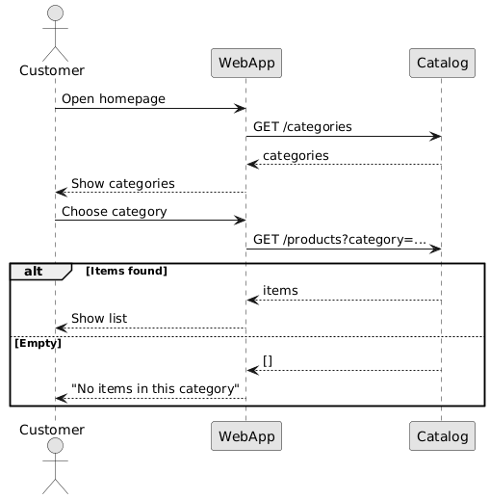
Figure 1. Browse Catalog by Category

Use Case #2: Check Local Stock Availability
- Actor: Customer
- Goal: Find out if the item is available in their location.
- Success Scenario:
  - On product page, customer enters postal code or allows location.
  - System validates input.
  - System checks inventory for that location.
  - Shows result: In stock / Low stock / Out of stock, with delivery or pickup options.
  - If available, customer adds item to cart.
- Error Scenarios:
  - Case 1: Wrong postal code >> System asks to enter again.
  - Case 2: Out of stock in that region >> System shows ‘Notify me’ or nearby region option.
  - Case 3: Inventory check fails >> System shows ‘Couldn’t check stock right now. Please try again’.
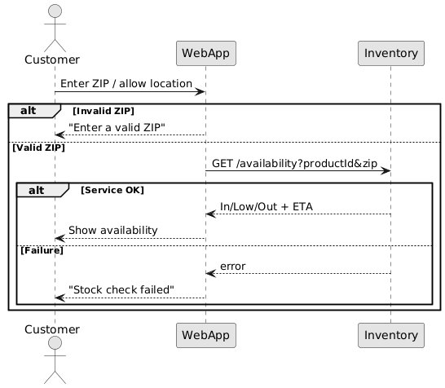
Figure 2. Check stock availability

Use Case #3: Add Item to Cart & Place Order
• Actor: Customer
• Goal: Order an available product.
• Success Scenario:
- Customer clicks Add to Cart.
- System adds product with quantity = 1.
- Customer can change quantity and clicks Checkout.
- Enters shipping details and chooses delivery/pickup option.
- Reviews order summary with condition labels, quantities, and total.
- Confirms order → System saves order and shows confirmation page with order ID.
• Error Scenarios:
- Case 1: Stock changed (if not available) >> System updates cart and shows alternatives.
- Case 2: Quantity more than stock >> System reduces to available quantity and alerts customer.
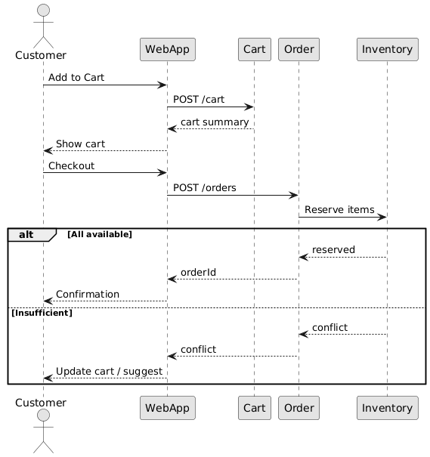
Figure 3. Add Item to Cart & Place Order

Use Case #4: Search & Filter by Condition
- Actor: Customer
- Goal: Quickly search and narrow products by category or condition.
- Success Scenario:
  - Customer enters a keyword in search like ‘Game Boy’.
  - System shows matching results.
  - Customer applies filters: Category = Gaming Consoles; Condition = Second-hand.
  - System updates and shows filtered items with counts.
  - Customer opens a product page.
- Error Scenarios:
  - Case 1: No results found >> System shows ‘No matches, clear filters to try again.’
  - Case 2: Both conditions unchecked >> System asks to select at least one.
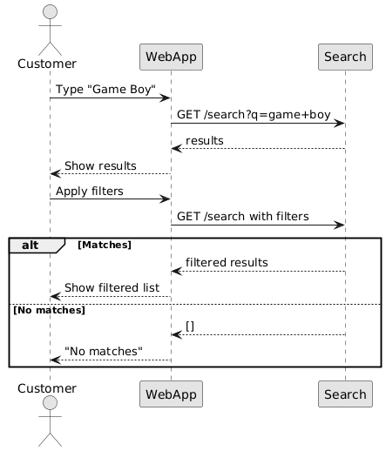
Figure 4. Search and Filter by condition

Use Case #5: Save for Later / Wishlist
- Actor: Customer
- Goal: Save an item to check later.
- Success Scenario:
  - Customer clicks Save / Wishlist on product.
  - System adds item to saved list.
  - Customer can open wishlist later and go back to product.
- Error Scenarios:
  - Case 1: Save action failed >> System shows ‘Could not save item, try again’.
  - Case 2: Item later unavailable >> System marks it as “Unavailable” in wishlist.
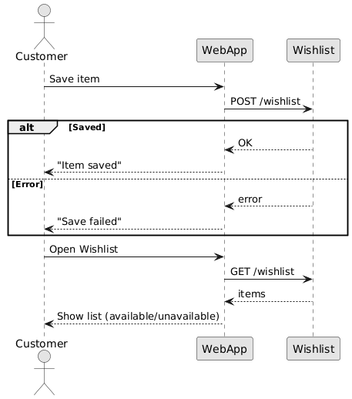
Figure 5. Save product for later
3. Functional Requirements

Functional Requirements for Use Case #1: Browse Catalog by Category
• Requirement ID: FR-001 Browse by Category i.e. list items with title, price and condition.
• Use Case Reference: Use Case #1: Browse Catalog by Category
• Trigger: Customer opens the homepage and clicks a category, for example the customer selects ‘Retro Gaming Consoles’ from the navigation bar or the category list.
• Preconditions:
- At least one category exists in the catalog.
- The WebApp can reach the catalog database and read catalog data.
• Success Flow:
- WebApp requests the category list from catalog.
- WebApp displays the available categories.
- Customer selects a category.
- WebApp requests products for that category with default sort and page = 1.
- Catalog returns a collection of products showing the details such as id, title, price, condition and also thumbnail.
- WebApp renders a grid style list showing thumbnail, title, price and a condition badge (first-hand or second-hand).
- Customer may scroll or can switch pages if multiple products available or switch category which in this case the WebApp repeats Steps 4 to 6.
• Alternative Flows:
• Alternative Flow 1 - Sort or Basic Filter inside browse:
Customer changes sort for instance the price from low to high. WebApp re requests products with the sort parameter and re renders the list.
• Alternative Flow 2 - Direct Link to Category URL:
If a customer opens ‘/category/retro-consoles’ then the WebApp loads that category directly and shows the list.
• Postconditions:
- The selected category is visually active or highlighted in the UI.
- A list i.e. possibly empty of products for that category is visible to the customer.

• Error Flows:
• Error1 Empty Category:
Catalog returns an empty array and shows ‘No items in this category yet’ and a link to other categories.
• Error2 Load Failure (network timeout):
Request fails and show the message ‘Couldn’t load items, please reload” with a Reload action.
• Error3 Invalid Category:
Category id not found and then the page Shows a message ‘Invalid Category’ or ‘Category Not Found’ and return to the category list.

• Requirement ID: FR-002 Product Details Page showing images, description and condition badge
• Use Case Reference: Use Case #1: Browse Catalog by Category
• Trigger: Customer clicks a product card from the category list or opens a direct product URL ‘/products/id’.
• Preconditions:
- The product exists and is visible in the catalog.
- The WebApp can reach the Catalog data source.
• Success Flow:
- WebApp requests product details by id or slug.
- Catalog returns product data: id, title, long description, price, condition (First-hand / Second-hand), image gallery (≥1 URL), category, basic specs.
- WebApp renders the Product Details page with:
  - Image gallery (primary image + thumbnails)
  - Title and long description
  - Price
  - Condition badge (First-hand / Second-hand)
  - Category breadcrumb
  - Add to Cart button (may be disabled until availability is confirmed)
  - Check Availability control (links to FR-004)
4. Customer can go back to the category listing or move ahead to availability check / cart.

• Alternative Flows:
• Alternative Flow 1 - Open via Direct Link:
Customer opens ‘/products/id’ from external source then the WebApp loads the product directly and skips the category page.
• Alternative Flow 2 - Direct Link to Category URL:
If a customer opens ‘/category/retro-consoles’ then the WebApp loads that category directly and shows the list.
• Postconditions:
- Product details are shown and customer can proceed to Check Stock (FR-004) or Add to Cart (FR-005).
• Error Flows:
• Error1 Product Not Found or Removed (404):
Show a message ‘This item is no longer available’ with a link back to the previous category.
• Error2 Load Failure (network timeout):
Request fails and show the message ‘Couldn’t load items, please reload” with a Reload action.
• Error3 Partial Data:
If some non-critical fields are missing then render available fields and display placeholders for missing parts.

Functional Requirements for Use Case #2: Check Local Stock Availability
• Requirement ID: FR-003 ZIP or Postal Code and Validating Input
• Use Case Reference: Use Case #2: Check Local Stock Availability
• Trigger: Customer is on the Product Details page and clicks on Check Availability and then enters a ZIP or postal code or can also choose their Use My Location feature.
• Preconditions:
- The Product Details page is loaded with a valid productId.
- The availability UI (input field + button) is visible and enabled.
• Success Flow:
- Customer types a postal code or clicks Use My Location feature.
- WebApp validates input on the client side i.e. things like format or length and a few country-specific rules if implemented in case.
- If using location, WebApp converts geolocation into postal or region code (browser API or local lookup).
- On valid input, the WebApp enables the Check button and prepares request parameters which looks like { productId, regionCode }
• Alternative Flows:
• Alternative Flow 1 - Saved address:
If a previously used region exists, WebApp pre-fills the field; customer can edit before submitting.
• Postconditions:
- A validated region Code is ready to send to the inventory or to the availability service.
- Invalid inputs are blocked from submission (button disabled).
• Error Flows:
• Error1 Invalid ZIP or postal code:
Show a message which says ‘Enter a valid ZIP or postal code’ and also highlight the field and do not send the request.
• Error2 Location permission denied or unavailable:
Keep manual entry active and show something like ‘Location not available. Kindly enter ZIP code instead’.
• Error3 Client-side validation error for non-numeric or too short or too long input:
Show an inline validation message and return focus to the field.

• Requirement ID: FR-004 Check Local Stock Availability by Region.
• Use Case Reference: Use Case #2: Check Local Stock Availability
• Trigger: A valid region Code is available from FR-003 and then the customer clicks Check Stock or the WebApp auto queries.
• Preconditions:
- From FR-003 completed successfully with a valid region Code.
- The WebApp can reach the Inventory data source.
• Success Flow:
- WebApp sends a request such as ‘GET /availability?productId=<id>&region=<code>’
- Inventory service looks up stock and fulfillment options for that region.
- Inventory returns payload which includes as follows:
  - quantity
  - estimated Delivery
  - status which checks in stock or out of stock
- WebApp renders an availability banner that if the product is in stock then shows an Add to Cart option and delivery or pickup estimates else if the product is out of stock then show notify me and suggest nearby regions if available.
- Customer proceeds and clicks Add to Cart or changes region and rechecks.
• Alternative Flows:
• Alternative Flow 1 - Nearby regions suggested:
If current region is out of stock then the WebApp offers nearby region Codes and selecting one repeats Steps 1 to 4 from Success Flow.
• Alternative Flow 2 - Cached result:
If the same product or region was checked recently then the WebApp may briefly show a cached status while refreshing in the background and then updates the banner.

• Postconditions:
- The product now has a current availability status linked to the chosen region on the page.
- If the product is in the stock then the Add to Cart path is not blocked for this region.
• Error Flows:
• Error1 Service failure or timeout:
Shows ‘Couldn’t check stock right now. Please try again.’ Keep previous page state and provide a Retry action.
• Error2 unsupported region:
Show a message which says ‘Enter a valid ZIP/postal code’ and return control to FR-003 input.

Functional Requirements for Use Case #3: Add Item to Cart & Place Order
• Requirement ID: FR-005 Add item to cart with default quantity set to 1 and adjust quantity if required

• Use Case Reference: Use Case #3: Add Item to Cart & Place Order
• Trigger: Customer clicks Add to Cart on the Product Details page that is only after availability is known.
• Preconditions:
- Product is visible with a valid productId.
- Current region status is in stock or out of stock from FR-004.
- A cart exists for the session
• Success Flow:
- WebApp loads the customer’s cart.
- WebApp adds the selected product with qty = 1 or increments if already in cart.
- WebApp fetches the cart summary that is details such as items, per-item price, condition badge and total.
- WebApp displays the updated cart page.
- Customer can increase or decrease quantity for any item and the WebApp updates line subtotal and cart total in real time.
• Alternative Flows:
• Alternative Flow 1 - Remove item:
Customer removes an item and then WebApp updates totals and shows an empty cart message if applicable in that case.
• Postconditions:
- Cart persists in session with accurate items, quantities and totals.
• Error Flows:
• Error1 Quantity exceeds available stock:
Cap quantity to available amount and show a message ‘Quantity reduced to available stock’.
• Error2 Product becomes unavailable:
Flag item as unavailable and then remove or disable it and suggest alternatives.
• Error3 Cart update failure:
Restore previous cart view and show a message which says ‘Couldn’t update cart. Kindly reload the page’.

• Requirement ID: FR-006 Checkout to Capture Shipping Option and Contact Details.
• Use Case Reference: Use Case #3: Add Item to Cart & Place Order
• Trigger: Customer clicks Checkout from the cart page.
• Preconditions:
- Cart contains more than or just 1 item with qty set to at least 1.
- Region is selected for fulfillment from FR-004.
• Success Flow:
- WebApp loads the Checkout page with order summary which includes the details such as items, quantities, prices and condition labels.
- Customer enters contact info and shipping address for delivery.
- Customer reviews delivery ETA and delivery cost if any.
- WebApp validates all required fields and enables Place Order.
• Alternative Flows:
• Alternative Flow 1 - Edit cart from checkout:
Customer adjusts quantities or removes items and then totals refresh inline.
• Postconditions:
- A complete order draft exists in WebApp memory with validated customer details and fulfillment selection.
• Error Flows:
• Error1 Pricing mismatch on refresh:
WebApp recalculates totals and prompts the customer to review changes before continuing.

• Requirement ID: FR-007 Confirm Order and then Show Order ID
• Use Case Reference: Use Case #3: Add Item to Cart & Place Order
• Trigger: Customer clicks Place Order on the checkout page.
• Preconditions:
- FR-006 is completed and validated.
- WebApp can reach Order and Inventory services.
• Success Flow:
- WebApp submits POST /orders with cart items, totals, region and customer details.
- Order service requests Inventory to reserve requested quantities per item or region.
- Inventory confirms reservation and the order service creates the order record and returns orderId and final summary.
- WebApp displays the Order Confirmation page with order ID, items with condition badges, quantities, totals and fulfillment details.
• Alternative Flows:
• Alternative Flow 1 - Partial availability at confirmation:
Order service returns a conflict with updated available quantities or suggested alternatives then the WebApp shows a conflict banner and routes the customer back to Cart with proposed changes.
• Postconditions:
- A persisted order exists with status PLACED.
- Cart is cleared or marked converted to prevent duplicate checkout.
• Error Flows:
• Error1 Items no longer available:
Order service returns a conflict then the WebApp updates cart quantities, disables checkout and suggests alternatives.
• Error2 Duplicate submission detected:
WebApp redirects to the existing Order Confirmation for the corresponding orderId.

Functional Requirements for Use Case #4: Search & Filter by Condition

• Requirement ID: FR-008 Keyword Search Across Title or Category
• Use Case Reference: Use Case #4: Search & Filter by Condition
• Trigger: Customer types a keyword in the Search bar and submits.
• Preconditions:
- Catalog and Search endpoints are reachable.
- At least one product exists in the catalog.
• Success Flow:
- WebApp captures the query string lets say q="game boy".
- WebApp sends GET /search?q=<query>&page=1&sort=relevance to the Search service.
- Search returns results items showing id, title, category, price, condition and thumbnail.
- WebApp renders the results list, shows visible result count and the active query.
- Customer can paginate or open a product detail from the list.
• Alternative Flows:
• Alternative Flow 1 - Direct Link:
Opening /search?q=<query> loads results directly.
• Postconditions:
- Current query and result count are displayed.
- Results list is visible and ready for further filtering which is covered in FR-009.
• Error Flows:
• Error1 No matches:
Show a message saying ‘No matches found. Kind try a different keyword’.

• Requirement ID: FR-009 Filters by Category and Condition.
• Use Case Reference: Use Case #4: Search & Filter by Condition
• Trigger: From a search results page mentioned in FR-008 the customer applies one or more filters such as Category and or or Condition.
• Preconditions:
- A search query has been executed or filters can apply to an empty query.
• Success Flow:
- Customer selects Category such as Gaming Consoles and Condition (First-hand or Second-hand).
- WebApp sends a request such as follows
GET /search?q=<query>&category=<cat>&condition=<cond>&page=1&sort=relevance.
- Search returns filtered results with updated counts.
- WebApp updates the list, highlights active filters and shows the filtered result count.
- Customer can clear filters individually or Clear All and the list refreshes accordingly.
• Postconditions:
- Results reflect the selected Category and Condition along with the keyword.
• Error Flows:
• Error1 Both conditions unchecked:
Prompt ‘Select at least one condition (First-hand or Second-hand)’ and block a submission until one is chosen.

Functional Requirements for Use Case #5: Save for Later / Wishlist

• Requirement ID: FR-010 Save or Unsave Item to a Personal Wishlist and View Wishlist

• Use Case Reference: Category Use Case #5: Save for Later / Wishlist
• Trigger:
- Save: Customer clicks Wishlist on a product card or the Product Details page.
- Unsave: Customer clicks Unsave on the same product to remove from the wishlist list.
- View: Customer opens the Wishlist page from the menu.

• Preconditions:
- Product exists with a valid productId.
- A wishlist exists for the current user.
- WebApp can reach the Wishlist data source.
• Success Flow:
Save
- Customer clicks Save on a product.
- WebApp sends POST /wishlist along with the Product ID.
- Wishlist service persists the item and returns OK plus the current wishlist count.
- WebApp updates UI such as the button toggles to Saved, header count increments and a brief pop-up shows ‘Item saved’.
Unsave
- Customer clicks Unsave on the product or on the wishlist page.
- WebApp sends DELETE /wishlist/<productId>.
- Wishlist service removes the item and returns OK with the updated count.
- WebApp updates UI such as button returns to Save
View Whistlist
- Customer opens Wishlist from menu.
- WebApp sends GET /wishlist.
- Wishlist service returns items with details such as productId, title, price, condition and thumbnail.
- WebApp renders the list with Available or Unavailable status and View Product links.

• Alternative Flows:
• Alternative Flow 1 - Save from listing:
Save directly from search or category cards without leaving the page.
• Alternative Flow 2 - Open product from wishlist:
Clicking a wishlist item opens the Product Details page as mentioned in FR-002.
• Postconditions:
- Wishlist reflects the latest saved or unsaved state with the correct item count.
- If viewing wishlist, customer sees up-to-date availability badges and can navigate to Product Details.

• Error Flows:
• Error1 Duplicate save:
Wishlist returns OK (already saved) and the WebApp keeps the Saved state i.e. no duplicate entries.
• Error2 Load wishlist failed:
Request fails and show the message ‘Wishlist unavailable, please reload’ with a Reload action.
• Error3 Save failed:
Keep button in Save state and show the message ‘Could not save item, please reload’ with a Reload action.
4. External Interface Requirements
4.1 Interaction Channels
4.1.1 Web User Interface (Primary)
• Audience
Customers: Browse, search, check stock, add to cart, checkout, wishlist.
Admins: Manage catalog, categories, inventory, and basic orders.
• Access
Modern desktop browsers with responsive layout for common laptop screens.
Mobile-friendly is nice to have but optional in Phase 2.
• Key Customer Pages/Components:
Home / Category listing (UC-1 / FR-001)
Product details (FR-002)
Availability check widget (UC-2 / FR-003, FR-004)
Search results + filters (UC-4 / FR-008, FR-009)
Cart & Checkout (UC-3 / FR-005, FR-006)
Order confirmation (FR-007)
4.1.2 HTTP/REST API (Used by the Web UI)
- Transport: HTTPS in production. HTTP okay for local dev.
- Base Path: /api/* (recommend namespace v1, for example /api/v1/products).
- Auth: Not in scope for Phase 2. Use an anonymous session/cart id.
• Customer:
Customers use a small set of endpoints to shop smoothly. They call /api/v1/categories to see categories, /api/v1/products and /api/v1/products/{id} to browse and view product details, /api/v1/availability to check stock by product and region, and /api/v1/search to find items by keyword. For buying, they use the cart and order flow: POST /api/v1/cart, PATCH /api/v1/cart/items/{productId}, GET /api/v1/cart, and finally POST /api/v1/orders to place the order. For favourites, they use the wishlist with POST /api/v1/wishlist, DELETE /api/v1/wishlist/{productId}, and GET /api/v1/wishlist.
• Admin:
Admins keep the store data correct and fresh with simple CRUD. They manage products using POST /api/v1/admin/products, PATCH /api/v1/admin/products/{id}, and DELETE /api/v1/admin/products/{id}; manage categories with POST/PATCH/DELETE /api/v1/admin/categories{/{id}} and update inventory by region using PUT /api/v1/admin/inventory. For visibility, they can review orders with GET /api/v1/admin/orders (read-only in Phase 2).
4.2 Data Formats
4.2.1 Request/Response
- Encoding: UTF-8; Content-Type: application/json for API.
- File Uploads (Admin Images): multipart/form-data with fields file, altText?, productId.
- Currency & Numbers: Prices as decimal strings with two digits (e.g., "129.99"). Quantities are integers.
- Media: Image metadata stored with products; binary files under /media with generated names; thumbnail generation is optional in Phase 2.

4.2.2 External Systems & Integrations
- Geolocation / ZIP Resolution:
For Phase 2, local lookup table (ZIP > region code). Later on in upcoming phases may switch to external geocoding API.
- Email/Notifications (Optional but good):
  - Order confirmation email: via SMTP in dev (mailhog/mailcatcher) or mock. Template includes orderId, items, totals, and delivery/pickup info.
  - Back-in-stock notice: small queue to email when an OUT_OF_STOCK wishlist item becomes available.
- Payments: Not required in Phase 2. We only simulate order placement (totals calculated and payment later).
- Analytics/Logging: Simple page/view counters optional, security logging later.
4.3 Non-Functional Interface Expectations
- Browser Support: Latest Chrome/Firefox/Edge.
- Availability: Local single instance is fine. HA not needed in Phase 2.
- Error Surfaces: Friendly customer messages. API returns structured error JSON.
- File Size Limits: Image upload ≤ 5 MB per file (check on client and server).
- Rate Limits: Not required now (can add later).
4.4 Backup & Recovery
- We will take daily automatic backups of all important data such as products, categories, images/URLs, carts, orders, inventory by region, and wishlists.
- In case the system goes down, we should be able to bring it back within 4 hours with minimal data loss (use last successful backup + transaction logs).
4.5 Performance
- Normal page loads (home, category, product detail, search) should finish within 2 seconds on a regular campus/home network.
- Media actions like product image uploads (including basic checks like file size/type) should complete within 5 seconds.
- Cart updates (add/increase/decrease) should feel instant on UI, with server confirmation right after.
4.6 Scalability
- The system should grow smoothly as we add more users, products, and regions without big redesigns.
- As catalog size and uploads increase, browsing, search, and availability checks should stay responsive (keep the same performance targets) by using pagination, caching, and simple indexing.
4.7 Availability
- Target 99.9% uptime for the web app, especially during busy times (searching, adding to cart, and checking out).
- Any maintenance should be short and announced and we should try to do it in low-traffic windows.

5. References
- [1] P. Pocatilu, “Modeling e-commerce applications using UML,” Informatica Economica Journal, vol. 12, no. 1, pp. 71–75, 2008.
- [2] A. Turban, J. Outland, D. King, J. Lee, T. Liang, and D. Turban, Electronic Commerce 2023: A Managerial and Social Networks Perspective. Cham, Switzerland: Springer, 2023.
- [3] M. Hassenzahl and N. Tractinsky, “User experience – a research agenda,” Behaviour & Information Technology, vol. 25, no. 2, pp. 91–97, 2006.
- [4] J. Smith, “Why retro and vintage products are booming online,” Journal of Consumer Culture, vol. 23, no. 3, pp. 456–472, 2023.
- [5] Statista Research Department, “Global collectibles market size and growth forecast,” Statista, 2024.
- [6] R. Hernandez, “Nostalgia in commerce: The rise of retro shopping,” Harvard Business Review, 2022.
- [7] IEEE Software Requirements Specification (See https://ieeexplore.ieee.org/stamp/stamp.jsp?tp=&arnumber=720574)
- [8] IEEE Software Design Descriptions (See https://ieeexplore.ieee.org/stamp/stamp.jsp?tp=&arnumber=741934)

